Helium balloons and polar curves:

How high will a helium balloon go until it bursts?

Mathematics HL: IA

1 Introduction 3
2 Deconstructing the problem 4
3 Shape as a function f(x) 4
4 Shape as an algebraic curve 5
5 Polar form of equations 6
7 Surface area of a rotated polar curve 7
8 Volume of a rotated polar curve 8
9 Bernoulli’s lemniscate 8
10 Surface area of a rotated Bernoulli’s lemniscate 10
11 Volume of a rotated Bernoulli’s lemniscate 10
12 Bounding polar angles for the rotated part of Bernoulli’s lemniscate 11
13 Simplification of the surface area and volume formulas 12
14 Approximate test of the validity of the formulas by comparison to a sphere 12
15 Calculation of altitude 14
16 Evaluation 16
Bibliography: 16

1 Introduction
Choosing a topic for this exploration has shown to be a significant personal challenge. Unlike other subjects, a math investigation is not limited to a certain experiment and the quality of its measuring devices, nor is it restricted by a focused set of subject-specific rules. Since mathematics is present everywhere in the world and a mathematical exploration is limited solely by the boundaries of the explorer’s knowledge, there is a multitude of options to choose from.
When conducting an exploration, the explorers should put their abilities to a test and discover something new on the way. However, when electing my question, I repeatedly dived into realms of mathematics that were far beyond my current comprehension. Educated by this mistake, I have decided to choose a less complex, personally more amusing and interesting topic. I have decided to estimate how high will a helium balloon go until it bursts? It resonates with my background in physics and with my childish curiosity, which often leaves me pondering too long about ‘what if?’ scenarios such as this one.
Although the question may seem trivial at first, I explored it through a way which requires the application of mathematical concepts previously unknown to me. Thus, the true purpose of the question was to act as guidance on my journey through curves and polar coordinates. In this way, both my curiosity and the standards of a good exploration were fulfilled.

2 Deconstructing the problem
As helium has a lower density than air, a balloon filled with helium will fly up according to Archimedes’ principle. However, due to the nature of gases, the balloon will expand with the drop in atmospheric pressure. At a certain altitude, the surface area of the balloon will exceed the stretch factor of the material and the balloon will burst.
For the sake of efficiency, this problem was first broken down into several steps:

- Estimate the shape of a balloon with an equation
- Find the equation for the surface area of a balloon (integration).
- Find the equation for the volume of a balloon (integration).
- Research the maximum elongation of the material.
- Find the specific volume at the critical surface area.
- Calculate altitude at which this volume occurs.

Several physical factors at play were approximated or neglected. The main approximation being that the balloon expands uniformly, that is - it keeps its shape. The fact that helium diffuses through the walls of the balloon was completely disregarded. I do realize that this dramatically changes the prediction from reality, however, it allows me to put more emphasis on the mathematical side of this exploration.

3 Shape as a function f(x)
The first problem was to estimate the shape of 2D silhouette of the balloon (as drawn in Figure 3) with an equation which would later be integrated and rotated to yield the surface area and volume of the 3D object.
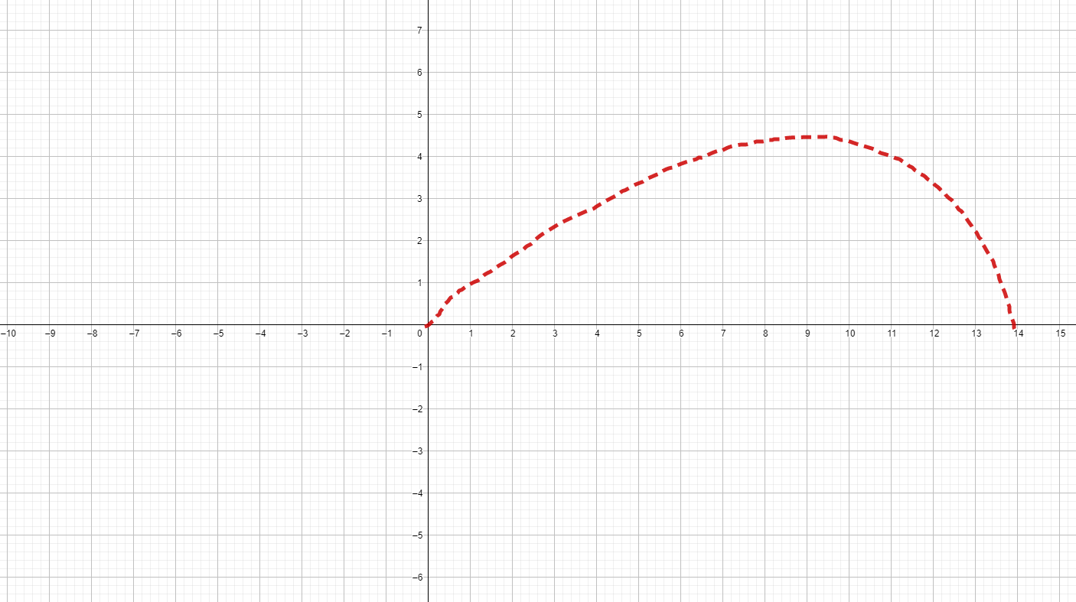

Figure 3.1
Half of a horizontal cross-section through the balloon

At first I didn’t plan to venture too deeply into the realm of curves. The circle $y^{2}+x^{2}=r{}^{2}$was the only type of curve not passing the vertical-line test that was included in the math syllabus. Given my limited background, I wished to describe only the upper half of the ballon shape with an equation in the form of a regular function.
To do this I had to first define some characteristics of the shape of my balloon. In order to do this, the use of mathematical analysis through derivation is convenient.

Let $f(x)$ be the function of the shape and have a domain D: $0≤x<x_{b}$
- There must be a point $x_{m}$ for which $f'(x_{m})=0$, where $\frac{1}{2}x_{b}<x_{m}<x_{b}$and $x_{m}∼\frac{3}{4}x_{b}$.
This is the point at which the balloon is the widest.
- $f''(x)<0$ for $0≤x<x_{m}$, thus the function is convex increasing throughout the whole interval. Similarly, it should be convex decreasing for $x_{m}<x<x_{b}$
This means that the increments in width per a certain distance get smaller as we approach the widest point.
- As $x→x_{b}$, $f'(x)→ -∞$
The tip of the balloon is at $x{}_{b}$, however this point can’t be included in this calculation, if I wish to describe the shape as a function. The function would fail the vertical line test.

By consideration of the approximate shape and the above stated conditions, it seemed that $f(x)$should either be a transformed product or a compound of functions $m(x)$ and $n(x)=sin(x)$limited by $0≤x<x_{b}$or that it is a part of a high-degree polynomial. Even after trying out several different forms of equations, a satisfying result was not reached. Plus, there was a recurring problem with the condition that $x→x_{b}$, $f'(x)→ -∞$.

4 Shape as an algebraic curve
At this point, it was getting obvious that the shape will have to be described with the use of an algebraic curve. The various curves potentially fitting the purpose of this investigation were the inner loop of the associated limacon (Figure 4.1), the inner loop of a Descartes’ leaf (Figure 4.2) and Bernoulli’s lemniscate (Figure 4.3). The last-mentioned variant resembled the shape of a helium balloon the most and so it was chosen for this exploration and will be described later on.

Figure 4.1  Limacon | Figure 4.2  Descarte’s folium

Figure 4.3
Bernoulli’s lemniscate

5 Polar form of equations
Prior to attempting to perform the exploration with the lemniscate of Bernoulli, knowledge of the polar coordinate system and polar equations was needed. After doing the research, I realized that the polar system is more effective and elegant when dealing with this type of curves. Plus, it was something new that I’d like to learn.
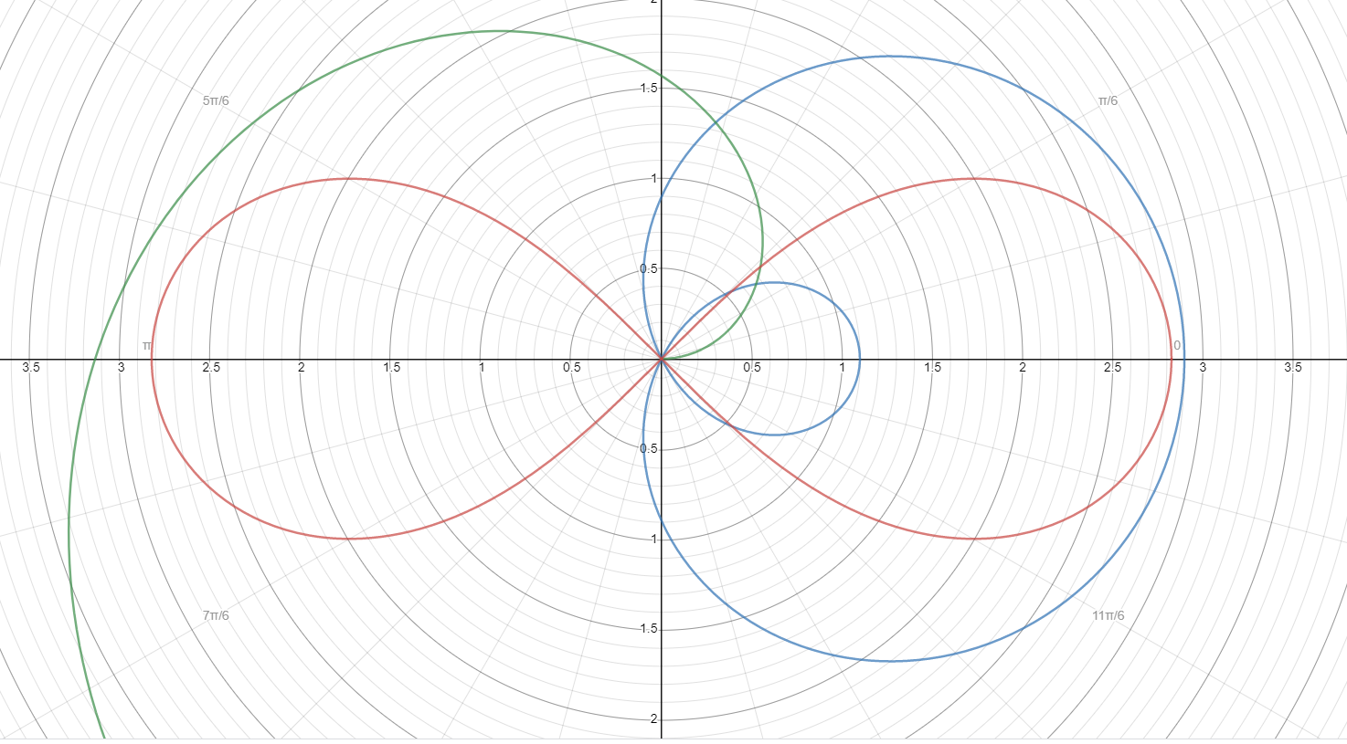
Figure 5.1
Polar coordinate system over Cartesian

Unlike Cartesian coordinates for a point, polar coordinates are not given by the distance of the point from the x and y axis. Rather, they are given by the distance r of the point P from the origin O and the angle $θ$between OP and the polar axis $θ=0$. The distance r is dependent on the polar angle $θ$, which can be summarised as:

$r=f(θ)$

The form of $f(θ)$is what determines the distinct shapes of different types of curves.

The Cartesian coordinates of the point on a curve are simply found through basic trigonometric ratios:
$x=rcos(θ)$
$y=rsin(θ)$

It must be noted that polar equations are a very elegant way of describing curves.

7 Surface area of a rotated polar curve
For a regular cartesian function, the equation for the surface area of the solid it forms when rotated through the x - axis is the following:
$A=2π\int_{a}^{b}{}y ds$
where $ds$ stands for the change in length of the curve. By dividing the length into infinitesimally small parts $ds$, each a hypotenuse of a right-angled triangle with adjacents $dx$and $dy$, $ds$may be expressed as:
$ds=\sqrt{1+{(\frac{dy}{dx})}^{2}}dx$

Understanding the various steps in deriving this formula took some time, however, it was necessary for converting it into its polar form. In order to do so, both y and $ds$were modified:

y yields the y - coordinate of a point on the curve, and so simply $y=rsin(θ)$

In order to express ds in polar terms, both $dx$and $dy$were changed.

Since:
$x=rcos(θ)$
$y=rsin(θ)$

then, by applying the product rule:
$\frac{dx}{dθ}=\frac{dr}{dθ}cos(θ)-rsin(θ)$

$\frac{dy}{dθ}=\frac{dr}{dθ}sin(θ)+rcos(θ)$

After a lengthy process of substitution into the original ds equation, this yields:
$ds=\sqrt{r^{2}+{(\frac{dr}{dθ})}^{2}}dθ$

And, finally, the surface area expressed in polar form:
$A=2π\int_{α}^{β}{}rsin(θ)\sqrt{r^{2}+{(\frac{dr}{dθ})}^{2}}dθ$

where the limits $α$ and $β$are the polar angles bounding the part of the curve that is being rotated around the x-axis.

I would like to point out that this process helped me understand the nature of the derivative more. Specifically, this is the first time I had to work with $\frac{dy}{dx}$ as an actual ratio, not just a symbol for the first derivative of y. The transformation also made me realize that derivatives can be taken for any two data sets experiencing change, not just the ones displayed on the y and x axis.

8 Volume of a rotated polar curve
The equation for the volume of a solid formed when a polar curve is rotated through the
x - axis is given by:
$V=\frac{2π}{3}\int_{α}^{β}{}r^{3}sin(θ)dθ$
where the limits $α$ and $β$are the polar angles bounding the part of the curve that is rotated around the x-axis*.

NOTE: I failed at deriving this formula myself. At first, I had attempted to derive it through the parametric formula $V=\left|π\int_{a}^{b}{}y^{2}\frac{dx}{dt}dt\right|$ where I set the polar angle $θ$ as the parameter t, however, after applying it (in the same way I will be applying this one further on), it did not pass any of my test of validity. For the reader’s interest, my formula for the volume of the specific polar curve I will be using (Bernoulli’s lemniscate) was $V=\left|-{{2\sqrt{2}πa}^{3}\int_{α}^{β}{}[sin(2θ)\sqrt{cos(2θ)} cos(θ) sin^{2}(θ)+\cos^{2}(2θ)sin^{3}(θ)]dθ}_{}\right|$

9 Bernoulli’s lemniscate
Now, after gathering all the necessary formulas, the exploration can proceed to simulate the helium balloon with the fitting shape of Bernoulli’s lemniscate.
In order to understand what it is, it is first necessary to explain Cassini’s ovals. These were first described by an Italian astronomer Giovanni Cassini who hypothesised that Earth orbits the Sun along one of these curves (Jarešová, Volf). Some Cassini ovals are shown in Figure 9.1.

Figure 9.1
Cassini ovals

A Cassini oval is a curve for which applies the following:

Let $F_{1}$and $F_{2}$be the foci of the curve and X be any point on the curve, then the product of the distances between the point and the individual foci is equal to some constant squared.

$\left|F_{1}X\right|⋅\left|F_{2}X\right|=k^{2}$

Let a be the distance of the foci from the origin O [0;0] , so $\left|F_{1}O\right|=\left|F_{2}O\right|=a$, then the above identity can be rewritten as the following, simply by using the distance between two point formula.

$\sqrt{{{(x+a)}^{2}+y^{2}}_{}}⋅\sqrt{{{(x-a)}^{2}+y^{2}}_{}}=k^{2}$

Solving for $x=0$ yields the y - intercepts:
$y= ±\sqrt{k^{2}-a^{2}}$

and for y = 0 yields they x - intercepts:
$x= ±\sqrt{a^{2}±k^{2}}$

By observation, if:

$a>k$ then there are no y - intercepts, 4 x - intercepts and the oval is split into two loops
$a<k$ then there are 2 y - intercepts, 2 x - intercepts and the curve is an oval
$a=k$ then there is 1 y - intercept and 2 x - intercepts and the curve resembles a bowtie

The last condition is what creates the Bernoulli’s lemniscate, which - for $x≥0$- resembles a helium balloon quite accurately. By quite a lengthy adjustment of the above equation, the equation for B. lemniscate is the following:

${(x^{2}+y^{2})}^{2}+2a^{2}(y^{2}-x^{2})=0$

By substituting for $x=rcos(θ)$ and $y=rsin(θ)$:

$r^{4}-2e^{2}r^{2}[\sin^{2}(θ)-\cos^{2}(θ)]=0$

And after suitable simplification yields the polar equation of the lemniscate of Bernoulli:
$r=a\sqrt{2cos(2θ)}$

and so:
$x=a\sqrt{2cos(2θ)}cos(θ)$
$y=a\sqrt{2cos(2θ)}sin(θ)$

10 Surface area of a rotated Bernoulli’s lemniscate
To express the surface area of the solid formed when the $x≥0$ part of the Bernoulli lemniscate is rotated through the x - axis, $r=a\sqrt{2cos(2θ)}$ is placed into $A=\left|2π\int_{α}^{β}{}rsin(θ)\sqrt{r^{2}+{(\frac{dr}{dθ})}^{2}}dθ\right|$ and so:

Firstly:
$r^{2}=$$a^{2}2cos(2θ)$

$\frac{dr}{dθ}=\frac{-a\sqrt{2}sin(2θ)}{\sqrt{cos(2θ)}}$

${(\frac{dr}{dθ})}^{2}=2a^{2}\frac{\sin^{2}(2θ)}{cos(2θ)}$

and so:
$A=\left|2π\int_{α}^{β}{}a\sqrt{2 cos(2θ)}sin(θ)\sqrt{a^{2}2 cos(2θ)+2a^{2}\frac{\sin^{2}(2θ)}{cos(2θ)}}dθ\right|$

which simplifies into:
$A=\left|4πa^{2}\int_{α}^{β}{}sin(θ)dθ\right|$
$A=\left|4πa^{2}[-cos(θ)]_{α}^{β}\right|$

11 Volume of a rotated Bernoulli’s lemniscate
To express the volume of the solid formed when $x>0$part of the Bernoulli lemniscate is rotated through the x - axis, $r=a\sqrt{2cos(2θ)}$ is placed into $V=\frac{2π}{3}\int_{α}^{β}{}r^{3}sin(θ)dθ$:

$V=\frac{2π}{3}\int_{α}^{β}{}a^{3}2\sqrt{2}cos(2θ)\sqrt{cos(2θ)}sin(θ)dθ$
and so:
$V=\frac{2\sqrt{2}πa^{3}}{3}\int_{α}^{β}{}cos(2θ)\sqrt{cos(2θ)}sin(θ)dθ$

Due to the complexity of the integral, the antiderivative was solved with the aid of technology in the upcoming calculation.

12 Bounding polar angles for the rotated part of Bernoulli’s lemniscate
In order to evaluate the aforementioned integrals, the polar angle limits $α$ and $β$ must first be set.
Since only the part of B. lemniscate situated in the 1st quadrant is being rotated, it is clear that the whole curve will be above the interval $0≤x≤x_{m}$where [0;0] and [$x_{m,}$; 0] are the only two x-intercepts. The polar angles $α$ and $β$will be the ones producing the boundaries $x=0$ and $x=x_{m}$.
By observation, the point [$x_{m,}$; 0] has the largest x-coordinate out of any point of the curve and so, since $x=a\sqrt{2cos(2θ)}cos(θ)$, it is clear that the largest x occurs at $θ=0$. Let this be the first polar angle limit $α$. For $α=0$ , $x=a\sqrt{2}$ and $y=0$, since $y=a\sqrt{2cos(2θ)}sin(θ)$, and so at $x_{m}$the curve is proven to cross the x-axis.
However, what is $β$? At first, I had thought that $α=0$ and $β=\frac{π}{2}$ can be used, since the 1st quadrant is located in between these two polar angles, however, the antiderivatives for the volume contained $\sqrt{cos(2θ)}$, which obviously fails to yield a real answer for anything above $θ=\frac{π}{4}$, and so I realized that $β$must only be as large as the polar angle needed to produce the point $[0;0]$- by observation of the shape of the B. lemniscate in the 1st quadrant, it is clear that the polar angle is the largest at the origin, and so it serves as the upper limit of the integral.
I suspected that $β=\frac{π}{4}$ , given that as the curve approaches the origin, it resembles the line $y=x$- and clearly the angle between $y=x$and the x-axis is equal to $\frac{π}{4}$, or in other words that at [0;0], $\frac{dy}{dx}=1$. To confirm my hypothesis, I had to derive $\frac{dy}{dx}$in terms of the polar angle $θ$.

Firstly, $\frac{dy}{dx}$ is expanded to $\frac{\frac{dy}{dθ}}{\frac{dx}{dθ}}$, and then:
$y=a\sqrt{2cos(2θ)}sin(θ)$
$x=a\sqrt{2cos(2θ)}cos(θ)$

and so:
$\frac{dy}{dθ}= -\frac{sin(θ)sin(2θ) - cos(θ)cos(2θ)}{\sqrt{cos(2θ})}$

$\frac{dx}{dθ}= -\frac{cos(θ)sin(2θ) + sin(θ)cos(2θ)}{\sqrt{cos(2θ})}$

thus:
$\frac{dy}{dx}=\frac{sin(θ)sin(2θ) - cos(θ)cos(2θ)}{cos(θ)sin(2θ) + sin(θ)cos(2θ)}$

By calculation for $\frac{dy}{dx}=1$, it can be seen that:
$sin(θ)sin(2θ) - cos(θ)cos(2θ) =$$cos(θ)sin(2θ) + sin(θ)cos(2θ)$

which occurs at $θ=\frac{π}{4}$, as assumed.

If this polar angle is placed into $x=a\sqrt{2cos(2θ)}cos(θ)$ and $y=a\sqrt{2cos(2θ)}sin(θ)$, $x=0$ and $y=0$, the exact coordinates of the origin are obtained.
Thus, the upper polar angle limit $β$is equal to $\frac{π}{4}$.

Only after I had already done the calculation, did I realize that to arrive at the same angle, all that was necessary was the following set of equations:
$x_{β}=a\sqrt{2cos(2β)}cos(β)=0$
$y_{β}=a\sqrt{2cos(2β)}sin(β)=0$

However, at least I got to practice a portion of mathematical analysis.

13 Simplification of the surface area and volume formulas
Then, for simplification of the actual calculation, the obtained values for $α$ and $β$were placed into the formulas for the surface area and the volume. This allows for the elimination of the indefinite antiderivative, which turns into a specific numbers and makes the upcoming calculation more efficient.

$A=\left|4πa^{2}[-cos(θ)]_{0}^{\frac{π}{4}}\right|$

which is:
$A=2πa^{2}(2-\sqrt{2})$

and
$V=\frac{2\sqrt{2}πa^{3}}{3}\int_{0}^{\frac{π}{4}}{}cos(2θ)\sqrt{cos(2θ)}sin(θ)dθ$

which is, approximately:
$V=\frac{2\sqrt{2}πa^{3}}{3} ⋅0.10870947$

14 Approximate test of the validity of the formulas by comparison to a sphere
Now, before applying the formulas for the purpose of my question, I had to somehow test for their validity. A fitting test was to compare the values for a specific a to the values of a sphere of corresponding proportions. Although not perfectly a semi-circle, the inspected part of B. lemniscate does resemble it.
By corresponding proportions, the following is meant:

- If the ‘width’ of the balloon $x_{m}$ (x-coordinate at $θ=0$) is d, then the radius of the corresponding circle is $\frac{d}{2}$. It is clear that $d=a\sqrt{2}$.

To test the similarity, let $d=1$m. Then:

$a=\frac{1}{\sqrt{2}}$

$r=0.5$

S. Area of the B. lemniscate, calculated from $2πa^{2}(2-\sqrt{2})$: $A_{b}=1.8403$m²

S. Area of the sphere, calculated from $4πr^{2}$: $A_{s}=π$m²

Volume of the B. lemniscate, calculated from $\frac{2\sqrt{2}πa^{3}}{3} ⋅0.10870947$: $V_{b}=0.114$m³

Volume of the sphere, calculated from $\frac{4πr^{3}}{3}$: $V_{s}=0.524$m³

The difference between the values seemed too large at first, since the assumption from the observation of the lemniscate was that it is similar in shape to a semi-circle, and thus should have similar both volume and surface.
However, only after this did I realize that mathematical analysis may be used to determine the similarity/difference of the two curves more exactly. All I needed to assure me about the validity of the two formulas was to determine the height of the maxima of a B. lemniscate.
A semi-circles maximum occurs at $y=r$, so, by keeping the above stated notation, $y_{s}=0.5d$. But what is the y-coordinate of the maximum of a B. lemniscate?

From the definition of a maximum, $\frac{dy}{dx}=0$ and $\frac{dy}{dx}$ has already been defined. So:
$\frac{dy}{dx}=0=$$\frac{sin(θ_{m})sin(2θ_{m}) - cos(θ_{m})cos(2θ_{m})}{cos(θ_{m})sin(2θ_{m}) + sin(θ_{m})cos(2θ_{m})}$

$0=$$sin(θ_{m})sin(2θ_{m}) - cos(θ_{m})cos(2θ_{m})$

(solved graphically by finding the intercept of $f(x)=sin(θ_{m})sin(2θ_{m})$and $g(x)=cos(θ_{m})cos(2θ_{m})$)

$θ_{m}=\frac{π}{6}$

By substituting into $y=a\sqrt{2cos(2θ)}sin(θ)$ it is clear that the maximum height of any B. lemniscate is:
$y_{b}=a\sqrt{2}⋅0.3536$

or

$y_{b}=0.3536 d$

and so:
$\frac{y_{b}}{y_{s}}=\frac{0.3536 d}{0.5 d}=0.707$

Meaning that on an equal domain - for the same ‘width’ - the semi-circle will be 1.4x higher than a B. lemniscate. Although this does not cause much difference in 1 dimensional quantities such as height, it will result in significant variations once the curve is rotated, enlarging the difference between the surface areas (square effect), but even more between the volumes (cube effect).
This explained the difference calculated in the above example and gave me confidence to apply the formulas in the final step of this exploration.

15 Calculation of altitude
Finally, once that all the necessary formulas were derived and tested, the answer to the overarching question of a balloon’s final altitude may be found.
Firstly, the initial conditions of the balloon after filling must be set.
Suppose the balloon is made out of natural rubber latex (NRL) and before filling has a ‘width’ of 0.1 m - the largest x-coordinate of the curve approximated to be Bernoulli’s lemniscate. The balloon is kept at standard room temperature and filled up at sea level. Then:

- $a_{0}=\frac{0.1}{\sqrt{2}}≈0.0707$m

- initial surface area $A_{0}=2π{a_{0}}^{2}(2-\sqrt{2})$ is:

$A_{0}=1.8403 ×10^{-2}$m²

- initial volume$V_{0}=\frac{2\sqrt{2}π{a_{0}}^{3}}{3} ⋅0.10870947$ is:

$V_{0}=1.1384×10^{-4}$m³

- The altitude at sea level is $h_{0}=0$m

- The atmospheric pressure at sea level $p_{0}=101 325$Pa

- The initial temperature of the gas $T_{0}=293$K

To reiterate what was stated in the introduction, as the helium balloon flies up, it expands as a result of the drop in the outside pressure due to elevation. At a certain point, the elasticity of NRL is not enough and the balloon breaks. The elongation factor of NRL is 6,5 and so the balloon burst when its surface area is 6.5x the initial surface area (Schafer) . Then:

$A_{f}=6.5A_{0}$

which, after algebraic simplification, yields:

$a_{f}=\sqrt{6.5}a_{0}$

This is necessary because the final altitude is calculated with the use of the final volume of the balloon, which is:

$V_{f}=\frac{2\sqrt{2}π{{(\sqrt{6.5}a}_{0})}^{3}}{3} ⋅0.10870947$

$V_{f}=1.887×10^{-3}$m³

At this point, the ideal gas law $pV=nRT$, where p is the pressure of the gas, V the volume, T the temperature, n the no. of moles in the gas and R the gas constant, must be employed.
Since the diffusion through the walls of the balloon is assumed to be zero, $nR$ is constant. Then, as the balloon rises up, and due to the drop in atmospheric pressure and temperature, changes p, V, T accordingly (the pressure and temperature of the gas change to equal the state of the outside):

$\frac{p_{0} V_{0}}{T_{0}}=\frac{p_{f}{ V}_{f}}{T_{f}}$

$\frac{p_{0} V_{0}}{T_{0} { V}_{f}}=\frac{p_{f}}{T_{f}}$

by substituting with the above-stated quantities, the ratio between the pressure and the temperature at the point of bursting is:

$\frac{p_{f}}{T_{f}}$= 20.86

The atmospheric pressure and temperature both decrease with amplitude. The magnitudes of both quantities for specific altitudes were measured throughout years of scientific research and summarised in the International Standard Atmosphere in Elevation. Out of this table, I have taken out solely the pressures and temperatures at a given altitude and added the ratio at that specific altitude, since this is what is searched for (APPENDIX).

At 20 000 m the ratio is measured to be 25.51 and at 22 000 m it is 18.51 (Engineering Toolbox), and so - according to the methods used in this exploration - the altitude at which a helium balloon will burst is somewhere between 20 km to 22 km above sea level.

16 Evaluation
20 kilometres seems too high for a standard natural rubber helium balloon to go, perhaps a meteorological balloon out of a different material would reach such heights. The flaw in the unrealistic answer is undoubtedly a result of the vast approximations and neglections made through the process. To mention the main issues: the shape of a balloon obviously does not correspond with Bernoulli’s lemniscate completely; the elongation factor used in this exploration was one-dimensional, in a two dimensional stretch such as this one, it would break sooner; the thermodynamics processes as the balloon rises should not be as simplified as they were.
To improve these aspects, I should have had investigated polar curves more deeply, perhaps a different type of curve with some specific parameter would prove to be a better fit for modelling a balloon and determine the 2D stretch factor of the balloon myself through experimentation, this would have most likely yielded a lower, more accurate value.
Nevertheless, the most important part of this exploration was the mathematical way of arriving at the answer, not the answer itself. Personally, this has been an exciting exploration, but more importantly an educative one. Every mathematical step in the process has taught either something completely new or further developed my past knowledge. Although lengthy, this exploration was personally rewarding.

Bibliography:
“International Standard Atmosphere.” Engineering ToolBox, www.engineeringtoolbox.com/international-standard-atmosphere-d_985.html.
Miroslava, Jarešová, and Volf Ivo. “Matematika Křivek.” Fyzikální Olympiáda – Studijní Texty, fyzikalniolympiada.cz/texty/matematika/mkrivek.pdf.
“Objem Rotačních Těles.” Math.muni.cz, Masarykova Univerzita, www.math.muni.cz/~xschlesi/dp/web/i23.html.
Schäfer, Ronald. “CHAPTER 33 MECHANICAL PROPERTIES OF RUBBER.” (2001).

https://www.mtec.or.th/wp-content/uploads/2018/04/mechanical-properties_rubber.pdf

APPENDIX
International Standard Atmosphere

Altitude (m) | Temperature (K) | Pressure (Pa) | P/T
0,00E+00 | 2,88E+02 | 1,01E+05 | 3,52E+02
5,00E+02 | 2,85E+02 | 9,55E+04 | 3,35E+02
1,00E+03 | 2,82E+02 | 8,99E+04 | 3,19E+02
1,50E+03 | 2,78E+02 | 8,46E+04 | 3,04E+02
2,00E+03 | 2,75E+02 | 7,95E+04 | 2,89E+02
2,50E+03 | 2,72E+02 | 7,47E+04 | 2,75E+02
3,00E+03 | 2,69E+02 | 7,01E+04 | 2,61E+02
3,50E+03 | 2,65E+02 | 6,58E+04 | 2,48E+02
4,00E+03 | 2,62E+02 | 6,17E+04 | 2,35E+02
4,50E+03 | 2,59E+02 | 5,78E+04 | 2,23E+02
5,00E+03 | 2,56E+02 | 5,41E+04 | 2,11E+02
5,50E+03 | 2,52E+02 | 5,05E+04 | 2,00E+02
6,00E+03 | 2,49E+02 | 4,72E+04 | 1,89E+02
6,50E+03 | 2,46E+02 | 4,41E+04 | 1,79E+02
7,00E+03 | 2,43E+02 | 4,11E+04 | 1,69E+02
7,50E+03 | 2,40E+02 | 3,83E+04 | 1,60E+02
8,00E+03 | 2,36E+02 | 3,57E+04 | 1,51E+02
8,50E+03 | 2,33E+02 | 3,32E+04 | 1,42E+02
9,00E+03 | 2,30E+02 | 3,08E+04 | 1,34E+02
9,50E+03 | 2,27E+02 | 2,86E+04 | 1,26E+02
1,00E+04 | 2,23E+02 | 2,65E+04 | 1,19E+02
1,05E+04 | 2,20E+02 | 2,45E+04 | 1,12E+02
1,10E+04 | 2,17E+02 | 2,27E+04 | 1,05E+02
1,15E+04 | 2,17E+02 | 2,10E+04 | 9,68E+01
1,20E+04 | 2,17E+02 | 1,94E+04 | 8,95E+01
1,25E+04 | 2,17E+02 | 1,79E+04 | 8,27E+01
1,30E+04 | 2,17E+02 | 1,66E+04 | 7,65E+01
1,35E+04 | 2,17E+02 | 1,53E+04 | 7,07E+01
1,40E+04 | 2,17E+02 | 1,42E+04 | 6,54E+01
1,45E+04 | 2,17E+02 | 1,31E+04 | 6,05E+01
1,50E+04 | 2,17E+02 | 1,21E+04 | 5,59E+01
1,55E+04 | 2,17E+02 | 1,12E+04 | 5,17E+01
1,60E+04 | 2,17E+02 | 1,04E+04 | 4,78E+01
1,65E+04 | 2,17E+02 | 9,57E+03 | 4,42E+01
1,70E+04 | 2,17E+02 | 8,85E+03 | 4,08E+01
1,75E+04 | 2,17E+02 | 8,18E+03 | 3,78E+01
1,80E+04 | 2,17E+02 | 7,57E+03 | 3,49E+01
1,85E+04 | 2,17E+02 | 7,00E+03 | 3,23E+01
1,90E+04 | 2,17E+02 | 6,47E+03 | 2,98E+01
1,95E+04 | 2,17E+02 | 5,98E+03 | 2,76E+01
2,00E+04 | 2,17E+02 | 5,53E+03 | 2,55E+01
2,20E+04 | 2,19E+02 | 4,05E+03 | 1,85E+01
2,40E+04 | 2,21E+02 | 2,97E+03 | 1,35E+01
2,60E+04 | 2,23E+02 | 2,19E+03 | 9,83E+00
2,80E+04 | 2,25E+02 | 1,62E+03 | 7,20E+00
3,00E+04 | 2,27E+02 | 1,20E+03 | 5,28E+00

